Muhammad Umar Farooq
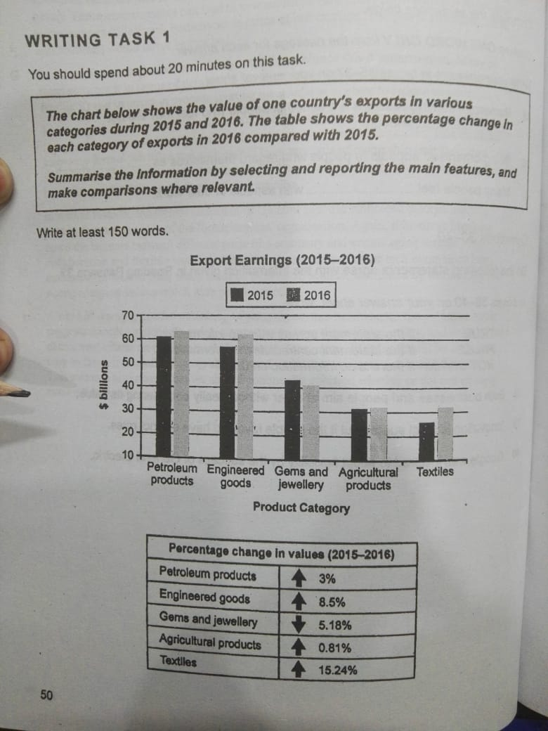
Writing Task

The provided char illustrates a county’s shipped in many goods’ classification between 2015 and 2016. While, the table showed the percentage of variation in income in each class over the time.
Overall, Both the chart and table demonstrated the carried out and revenue generated in different categories. While, Petroleum products had the bar high with increasing trends in contrast, Textile contributed minimal in this regard. Moreover, game and Jewellery expressed decline over the period.
Looking at the details, Petroleum products contributed the most in foreign trade with 3% increase, the country had 60 billion of trade in 2015 and rose to 64 by the 2016. However, Engineering goods comes on the second with increasing trends by 8.5% in earning. It was on approximately 56 billion in 2015 and jumped on 63.5. Games and Jewellery had generated the income about 43 in 2015 with decreasing fashion by 5.18% and approached on 38 billion.
The figures depicting that the country is the not the agricultural because, this is not contributing the export significantly however, the country exported the Agricultural products with almost stabilize, shipped and earned 32 billion in 2015 and tuck a small step with 0.81% to upward direction and reached on 32.8%.
Lastly, Textile had least contribution in export but expressed the noticeable improvement by the time, in 2015 total earning in textile by export was about 23 billion and risen with 15.24% and become the fastest grow category over the year and climbed on 35 billion of revenue.

